3rd Grade Spelling List
Unit 1: Dollars and Sense

Boom Town | What About Me? | Alexander, Who Use to Be Rich Last Sunday | If You Made a Million | My Rows and Piles of Coins
happen | pennies | using | clean | proud
lettuce | inches | getting | agree | shower
basket | plants | easiest | teeth | hour
winter | families | swimming | dream | amount
sister | bodies | heavier | grain | voyage
monster | glasses | greatest | coach | choice
supper | wishes | pleased | display | avoid
subject | pockets | emptied | window | thousand
lesson | lists | leaving | shadow | prowl
spelling | copies | worried | cheese | employ
napkin | parties | strangest | peach | bounce
collar | bunches | freezing | braid | poison
traffic | crashes | funniest | Sunday | annoy
suggest | supplies | angrier | float | appoint
puppet | pencils | shopped | thrown | broil
Challenge | Challenge | Challenge | Challenge | Challenge
skillet | accidents | included | entertain | however
picnic | libraries | occurred | complain | mountain
planet | mysteries | supplying | bleachers | coward
system | carpenters | scarier | willow | turmoil
pumpkin | merchants | happiest | wheat | chowder

3rd Grade Spelling List
Unit 2: Smart Solutions

Penguin Chick | A Day’s Work | Prudy’s Problem and How She Solved It | Tops and Bottoms | William’s House
finish | handle | sunglasses | splash | father
pilot | trouble | football | throw | chapter
even | simple | homework | three | other
wagon | people | haircut | square | alphabet
music | middle | popcorn | throat | watch
silent | table | railroad | strike | English
rapid | little | snowstorm | street | weather
female | gentle | earring | split | catch
lemon | poodle | scarecrow | splurge | fashion
pupil | pickle | blueberry | thrill | shrink
focus | noodle | butterflies | strength | pitcher
robot | saddle | lawnmower | squeak | flash
tulip | juggle | campground | throne | athlete
camel | uncle | sandbox | strawberry | trophy
salad | riddle | toothbrush | squeeze | nephew
CHALLENGE | CHALLENGE | CHALLENGE | CHALLENGE | CHALLENGE
resident | example | thumbtack | squid | northern
spinach | throttle | earthquake | squander | establish
climate | obstacle | scrapbook | arthritis | emphasis
tradition | miracle | courthouse | instrument | hyphen
innocent | muscle | whirlpool | strategy | challenge

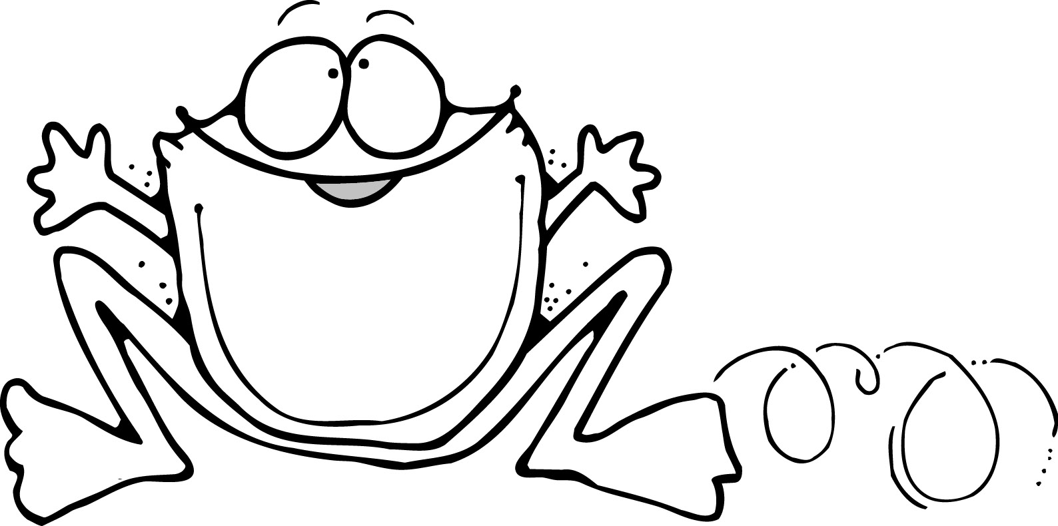

3rd Grade Spelling List
Unit 3: People and Nature

The Gardner | Pushing Up the Sky | Night Letters | A Symphony of Whales | Volcanoes: Nature’s Incredible Fireworks
let’s | unhappy | clock | beautiful | thumb
he’d | recall | large | safely | gnaw
you’ll | disappear | page | kindness | written
can’t | unload | mark | finally | know
I’d | mistake | kitten | spotless | climb
you’d | misspell | judge | worthless | design
haven’t | dislike | crack | illness | wrist
hasn’t | replace | edge | helpful | crumb
she’d | mislead | pocket | daily | assign
they’ll | disagree | brake | suddenly | wrench
when’s | rewrite | change | wireless | knot
we’d | unroll | ridge | quietly | wrinkle
they’d | unknown | jacket | fairness | lamb
wasn’t | dishonest | badge | cheerful | knob
didn’t | react | orange | painful | knit
CHALLENGE | CHALLENGE | CHALLENGE | CHALLENGE | CHALLENGE
should’ve | unfortunate | freckles | anxiously | wrestler
would’ve | discourage | advantage | thoughtfully | bologna
could’ve | uncomfortable | pledge | cautiously | cologne
needn’t | recycle | Kentucky | tardiness | honeycomb
you’ve | mispronounce | kingdom | breathless | knickknack



3rd Grade Spelling List
Unit 4: One of a Kind

Wings | Hottest, Coldest, Highest, Deepest | Rocks in His Head | America’s Champion Swimmer: Gertrude Ederle | Fly, Eagle, Fly
wolves | third | prepaid | dentist | monster
knives | early | midnight | editor | surprise
feet | world | overflow | artist | hundred
men | certain | outdoors | hostess | complete
children | dirty | outline | actress | control
women | herself | overgrown | swimmer | sample
sheep | earth | prefix | seller | instant
heroes | word | Midwest | tutor | inspect
scarves | perfect | pretest | tourist | pilgrim
mice | verb | midpoint | organist | contrast
geese | nerve | outgoing | lioness | explode
cuffs | worm | overtime | shipper | district
elves | thirsty | overdue | chemist | address
banjos | workout | outside | investor | substance
halves | earn | outfield | conductor | children
CHALLENGE | CHALLENGE | CHALLENGE | CHALLENGE | CHALLENGE
loaves | determine | precaution | announcer | merchant
beliefs | commercial | prediction | pharmacist | embrace
tomatoes | whirlwind | midsection | journalist | purchase
potatoes | worthwhile | overweight | commuter | curtsy
tornadoes | virtual | prehistoric | pianist | contract

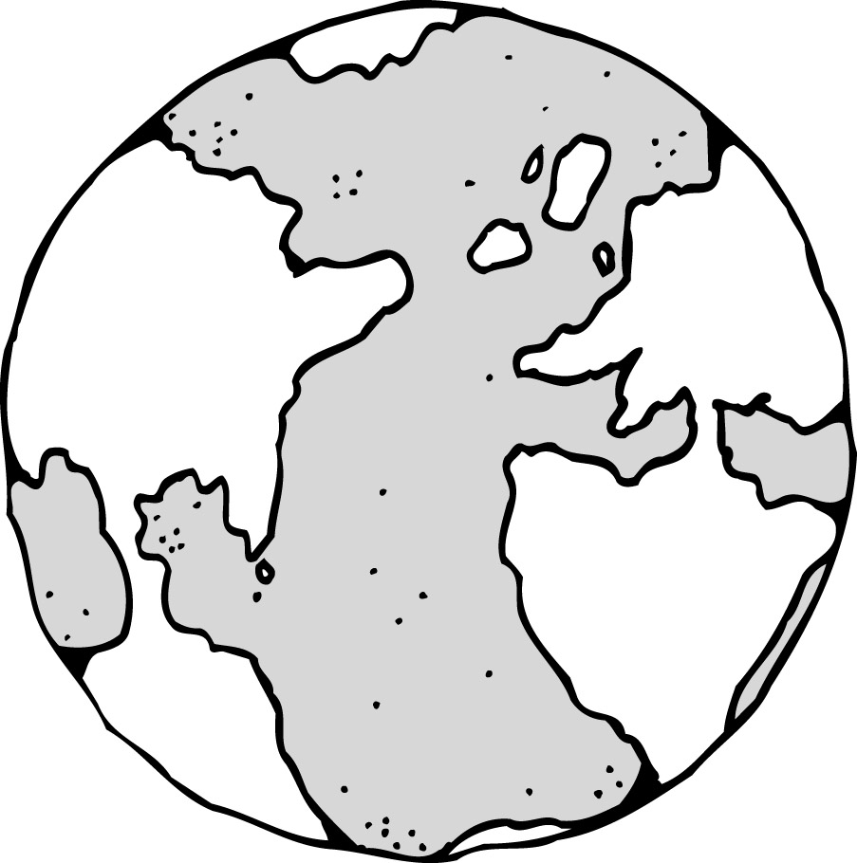

3rd Grade Spelling List
Unit 5: Cultures

Suki’s Kimono | How My Family Lives in America | Good-Bye, 382 Shin Dang Dong | Jalapeno Bagels | Me and Uncle Romie
create | to | small | thought | rocky
medium | too | almost | fought | foolish
piano | two | always | bought | rainy
idea | week | because | taught | childhood
radio | weak | straw | caught | selfish
video | our | drawn | walk | treatment
studio | hour | also | cough | movement
violin | stair | author | talk | neighborhood
duo | stare | false | daughter | childish
patio | flour | already | ought | parenthood
rodeo | flower | flaw | sought | crunchy
pioneer | write | sausage | brought | bumpy
trio | right | applause | trough | payment
stadium | new | walnut | chalk | sleepy
audio | knew | lawn | stalk | shipment
CHALLENGE | CHALLENGE | CHALLENGE | CHALLENGE | CHALLENGE
audience | their | awesome | sidewalk | assignment
radiate | there | altogether | distraught | livelihood
cereal | they’re | awning | afterthought | stylish
Creole | weather | faucet | overwrought | environment
recreation | whether | laundry | beanstalk | guilty

3rd Grade Spelling List
Unit 6: Freedom

The Story of the Statue of Liberty | Happy Birthday Mr. Kang | Talking Walls: Art for the People | Two Bad Ants | Elena’s Serenade
few | above | question | leadership | cloth
school | another | creature | gracefully | clothes
true | upon | furniture | refreshment | nature
goose | animal | division | uncomfortable | natural
fruit | paper | collision | overdoing | able
cookie | open | action | remarkable | ability
cushion | family | direction | carefully | mean
noodle | travel | culture | unbearably | meant
bookmark | afraid | vacation | ownership | deal
balloon | nickel | mansion | unacceptable | dealt
suit | sugar | fiction | impossibly | please
chew | circus | feature | reappeared | pleasant
glue | item | sculpture | unprepared | sign
Tuesday | gallon | vision | oncoming | signal
bushel | melon | celebration | misbehaving | signature
CHALLENGE | CHALLENGE | CHALLENGE | CHALLENGE | CHALLENGE
bamboo | character | fascination | outrageous | equal
mildew | cardinal | legislation | incomprehensible | equation
soothe | Oregon | manufacture | undoubtedly | equator
barefoot | particular | possession | independence | major
renewal | dinosaur | declaration | disadvantage | majority

